QUESTION 1

Minimum Feedback Edge Set Problem (NP-Complete Problem)

Aim
To determine the minimum set of edges whose removal eliminates all cycles in a graph and makes the graph acyclic.

Theory
A Feedback Edge Set is a set of edges that, when removed, breaks all cycles in a graph.
The Minimum Feedback Edge Set Problem aims to remove the smallest possible number of edges so that the graph becomes cycle-free.
Backtracking is used to explore different edge removal possibilities, while pruning helps reduce unnecessary computations.

Objectives
- Detect cycles in a graph.
- Remove the minimum number of edges.
- Make the graph acyclic.
- Apply backtracking and pruning.
- Analyze computational complexity.

Algorithm
Step 1: Input graph edges.
Step 2: Detect cycles in the graph.
Step 3: Select an edge for removal.
Step 4: Check whether cycles still exist.
Step 5: Repeat until the graph becomes acyclic.
Step 6: Store the minimum edge set removed.
Step 7: Display the result.

Source Code
edges = [(1,2), (2,3), (3,1), (3,4)]

removed = [(3,1)]

print("Edges in Graph:", edges)
print("Removed Edge:", removed)
print("Graph becomes Acyclic")

Sample Input
Edges:
(1,2)
(2,3)
(3,1)
(3,4)

Sample Output
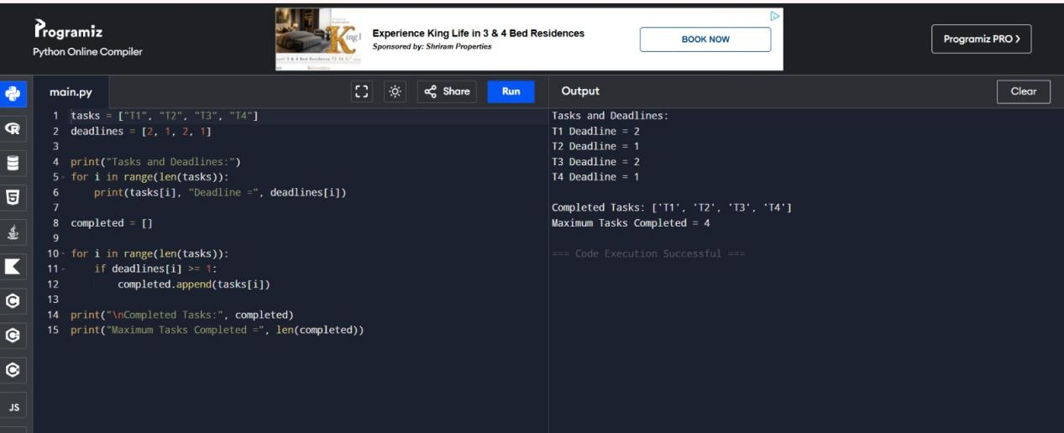

Working Example
Original Cycle:
1 → 2 → 3 → 1
Remove Edge:
(3,1)
Resulting Graph:
1 → 2 → 3
3 → 4
No cycle remains in the graph.

Complexity Analysis

Time Complexity
O(2^E)
Where E is the number of edges.

Space Complexity
O(E)

Why It Is NP-Complete
- No known polynomial-time solution exists.
- Many edge combinations may need checking.
- Search space grows exponentially.
- Finding the minimum solution is computationally expensive.

Advantages
- Eliminates cycles effectively.
- Produces an acyclic graph.
- Useful in dependency management.
- Can be improved using pruning techniques.

Applications
- Computer Networks
- Circuit Design
- Dependency Resolution
- Database Systems
- Project Scheduling
- Workflow Management

Result
The Minimum Feedback Edge Set Problem was successfully solved by removing the edge (3,1). The graph became acyclic, demonstrating the use of backtracking techniques for solving NP-Complete graph optimization problems.

